1. Bar Chart – Customer Age Distribution
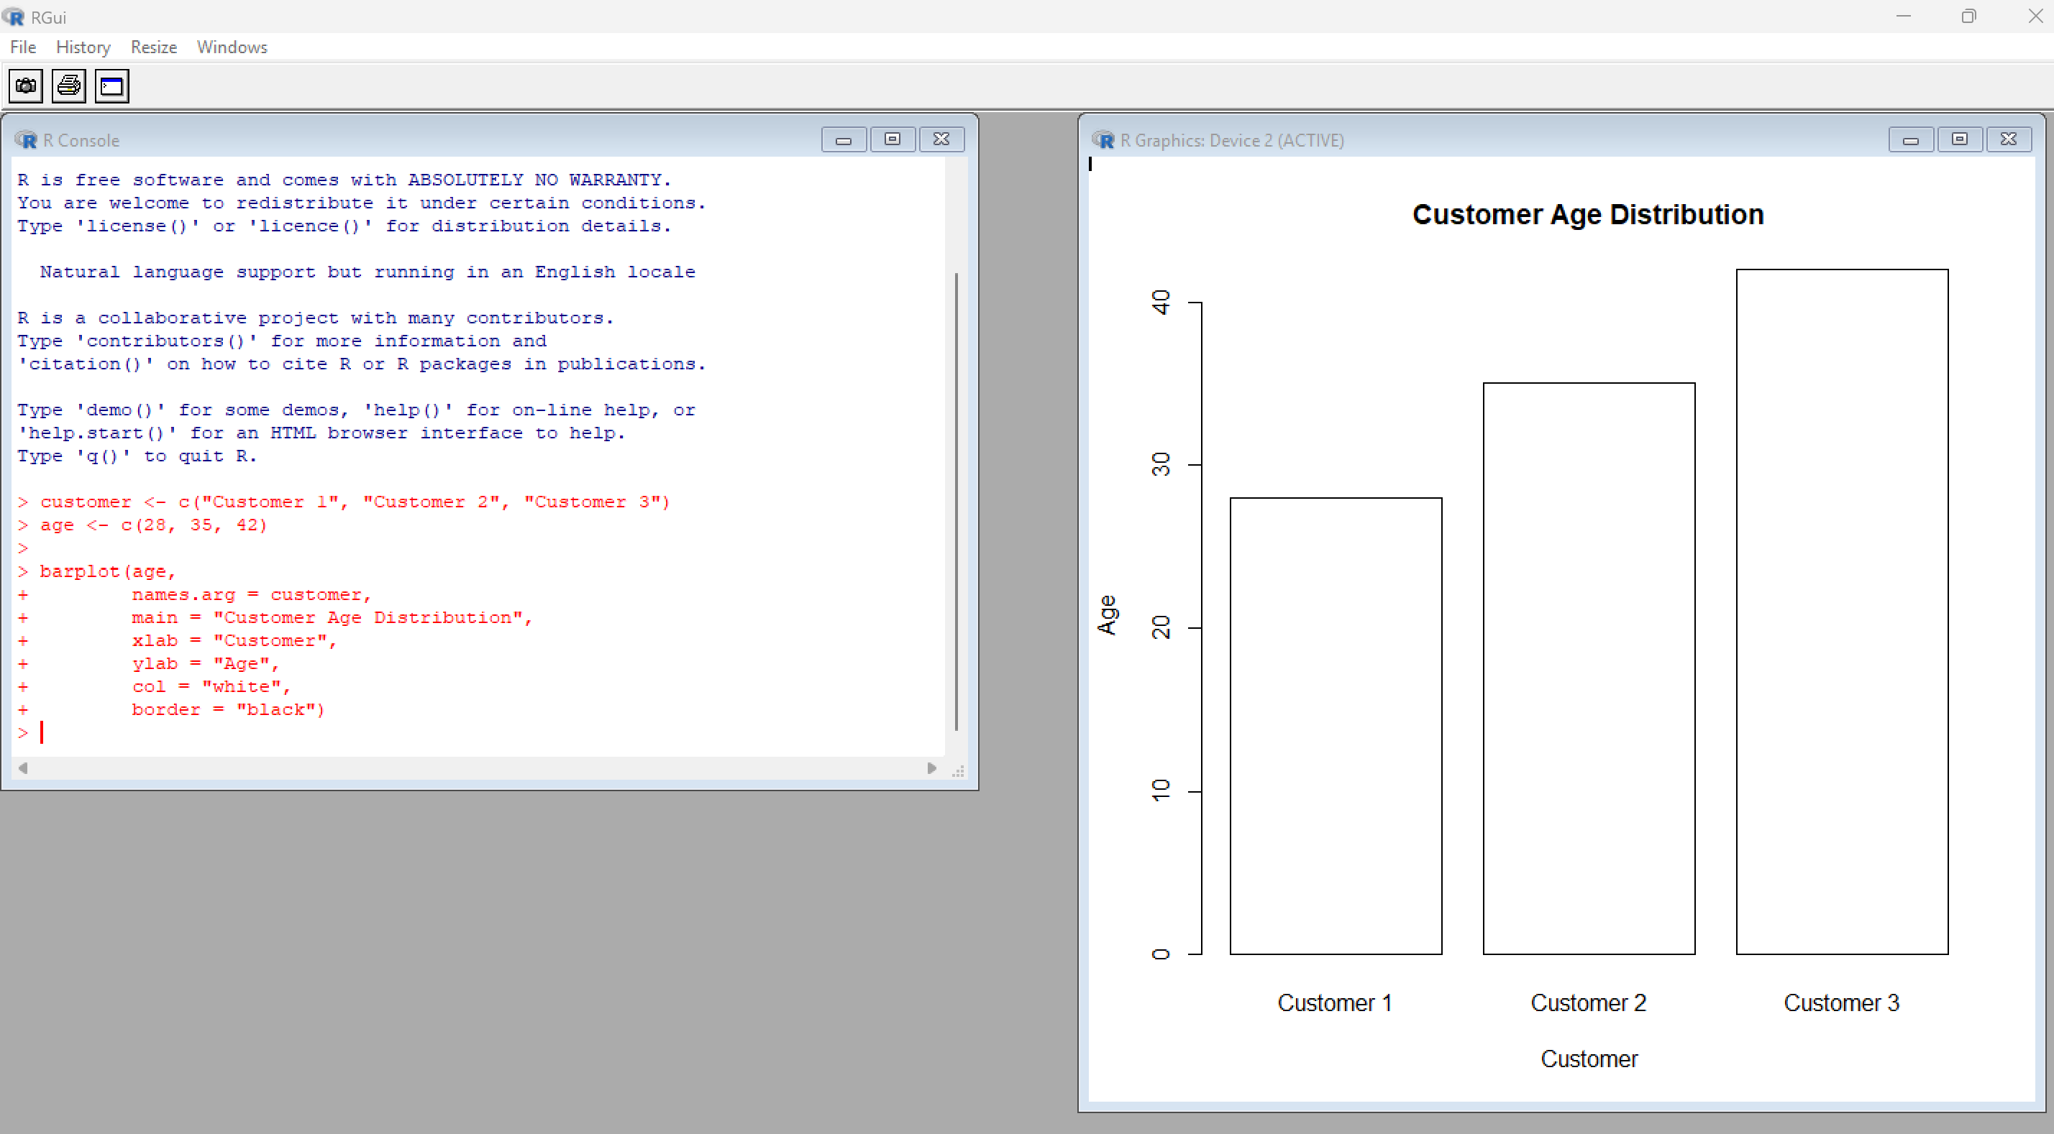

2. Pie Chart – Customers by Gender
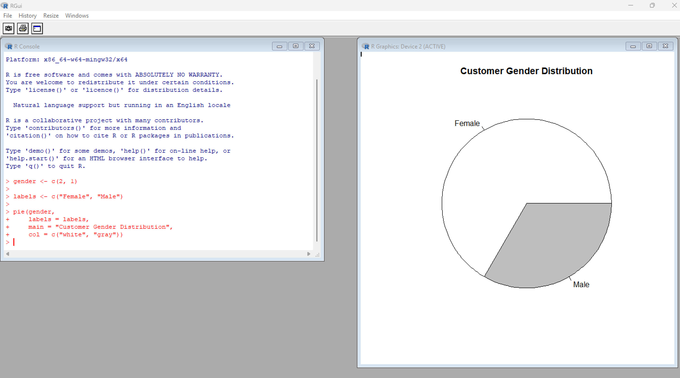

3. Table – Customer Demographics
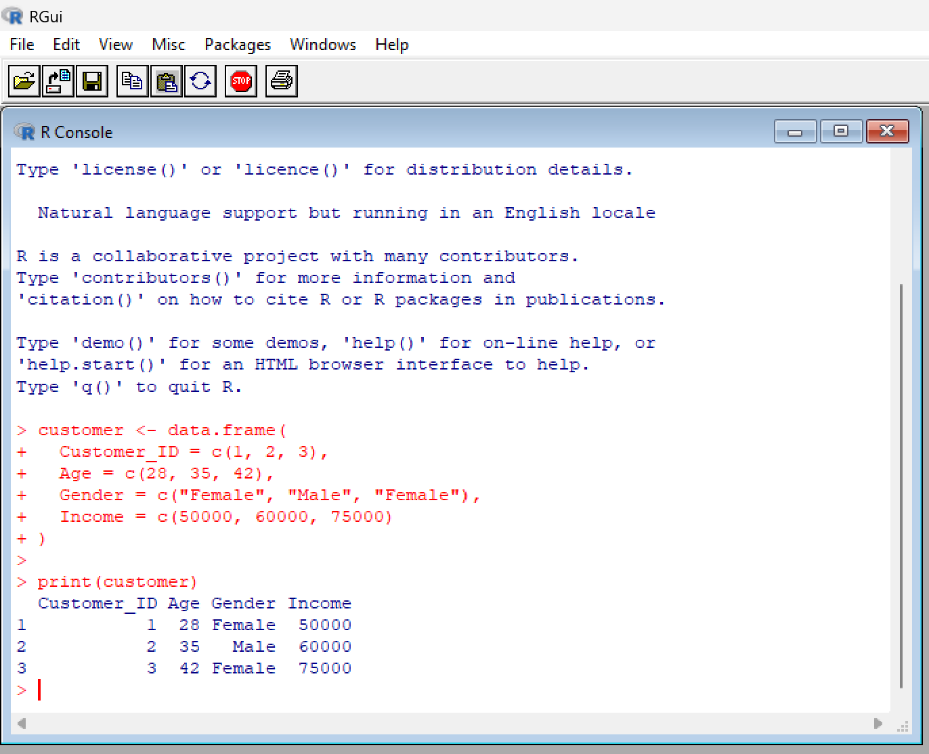

4. Tableau Dashboard
